How to Access Your Cashback Rewards

Once you log into Online Banking at Listerhill.com, choose your credit card account from the Accounts page.

Click “Get Info” in the menu below

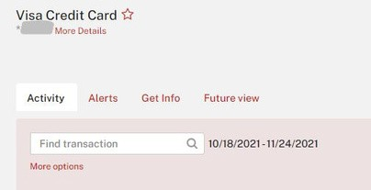

From The Account Home screen, click “Rewards” underneath your Cash Rewards credit card

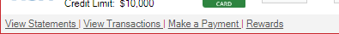

In the Rebate Mall screen, click “Cashbackmall” to go the Cash Back Mall

You will see a Redirect screen
Click Submit

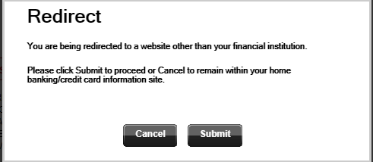

On the next screen click on “Redeem” at the top for cash back to Visa statement or deposit to share account.
Stay on current Home screen and use your cash back for shopping.

If your rewards balance is $5 or more, you can now choose to receive your cash back as a Visa statement credit (does not count toward your minimum monthly payment) or as a deposit to your share account.

Click Redeem to choose an option and enter additional information.
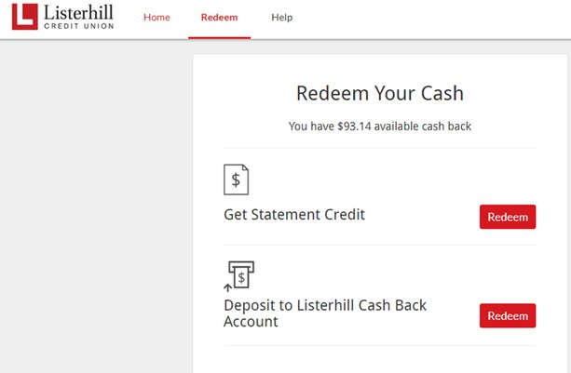
Cash to card (stmt credit) is 2-3 business days
Cash to account (deposit) is next business day

Once redemption is completed, log out of Cash Back Mall by clicking on your name in the top right corner and selecting Log Out.

